BLOSSOMS IN BLOOM MINI PAPER PUMPKIN BOX
By Tami Hewlett

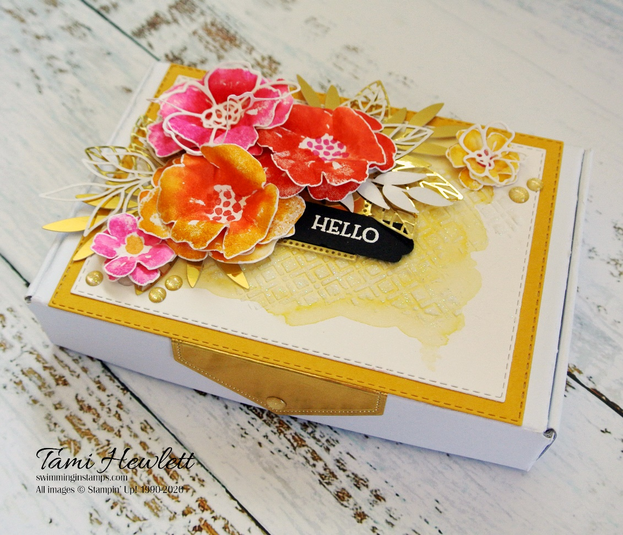

All images copyright © 1990-2017 Stampin’ Up! ®

Stampin’ Up! Supplies Used:

- Stamps: Blossoms In Bloom (152684)
- Inks: Magenta Madness, Poppy Parade, Bumblebee, Whisper White Craft
- Cardstock: Shimmery White, Bumblebee, Basic Black, & Gold Foil
- Designer Paper: Forever Gold Laser-Cut Specialty Paper
- Accessories: Mini Paper Pumpkin Box, Shimmery White Embossing Paste, White Stampin’ Emboss Powder, Gold Glitter Enamel Dots
- Tools: Die Cutting Machine, Many Layered Blossoms Dies, Stitched Rectangle Dies, Stitched Nested Labels Dies, Lovely Labels Pick A Punch, Heat Tool, Water Painters, Stampin’ Spritzer, Sponge Daubers, Palette Knife, Bone Folder, Silicon Craft Sheet
- Miscellaneous:, Tear & Tape Adhesive, Stampin’ Dimensionals, Hot Glue Gun

INSTRUCTIONS:

1. Assemble Mini Paper Pumpkin Box.
2. Use Stitched Rectangle Dies to cut largest rectangle from Bumblebee Cardstock and second largest rectangle from Shimmery White Cardstock.
3. Paint a quick watercolor wash on the Shimmery White layer with a Water Painter and Bumblebee ink. Let dry. Using one of the Forever Gold Laser-Cut rectangles as a mask, apply a thin coat of Shimmery White Embossing Paste with a Palette Knife on top of a Silicone Craft Sheet. Only cover a portion of the mask with the paste. Remove mask and clean Palette Knife immediately.
4. Use Stitched Nested Labels Dies (second largest) to cut Gold Foil. Fold so tip is flush with bottom of lid edge and adhere to Mini Paper Pumpkin Box with Tear & Tape.
5. Adhere two Stitched Rectangle Dies together and to box with Tear & Tape.
6. Remove the following Gold Laser-Cuts: Rectangle label with leaves and three individual white leaves shown in photo.
7. To stamp flowers, use Shimmery White Cardstock. Ink up large Blossoms In Bloom stamp with Bumblebee ink. Use a Sponge Dauber to add Poppy Parade to the middle of the flowers. Spritz stamp lightly with water and stamp. Repeat by inking up the stamp with Magenta Madness and sponging with Poppy Parade ink. Repeat again by inking up the stamp with Poppy Parade ink (no sponging.) Stamp dots in the center of the flowers, using Poppy Parade ink for the Bumblebee and Magenta Madness flowers and Magenta Madness ink for the Poppy Parade flowers.
8. Stamp two small flowers with Magenta Madness, by inking up the stamp and spritzing lightly before stamping. Stamp centers with Bumblebee ink. Stamp two more flowers using Bumblebee ink, spritzing before stamping, and then stamp the centers with Magenta Madness ink.
9. Use scissors to cut out three large Magenta Madness flowers, three large Bumblebee flowers, and two large Poppy Parade flowers. Trim close, cutting flowers apart where they meet. Also, cut out the four small flowers. Use a Bone Folder to break down the fibers and form 3D flowers.
10. Assemble flowers with hot glue.
11. Lay out flowers and laser-cuts as shown to ensure proper positioning. Adhere label with Dimensionals and flowers and remaining laser-cut leaves with hot glue.
12. Use Many Layered Blossom Dies to cut one small detailed flower and a portion of the large detailed die (only one complete large flower is needed) from Shimmery White Cardstock. Use scissors to trim down large detailed flower so only the flower remains.
13. Scrunch detailed flowers with fingers and adhere to the center of two flowers with a small drop of hot glue as shown in photo.
14. Cut a strip of Basic Black Cardstock ½” wide. Punch right side with Lovely Labels Pick A Punch. Stamp sentiment with White Craft ink and heat emboss with White Stampin’ Emboss Powder. Trim left side with scissors. Tuck under Bumblebee flower and adhere to laser-cut label with Seal.
15. Add Gold Glitter Enamel Dots to the top and Stitched Nested Label Die on the lid edge.
