Mixed Drinks
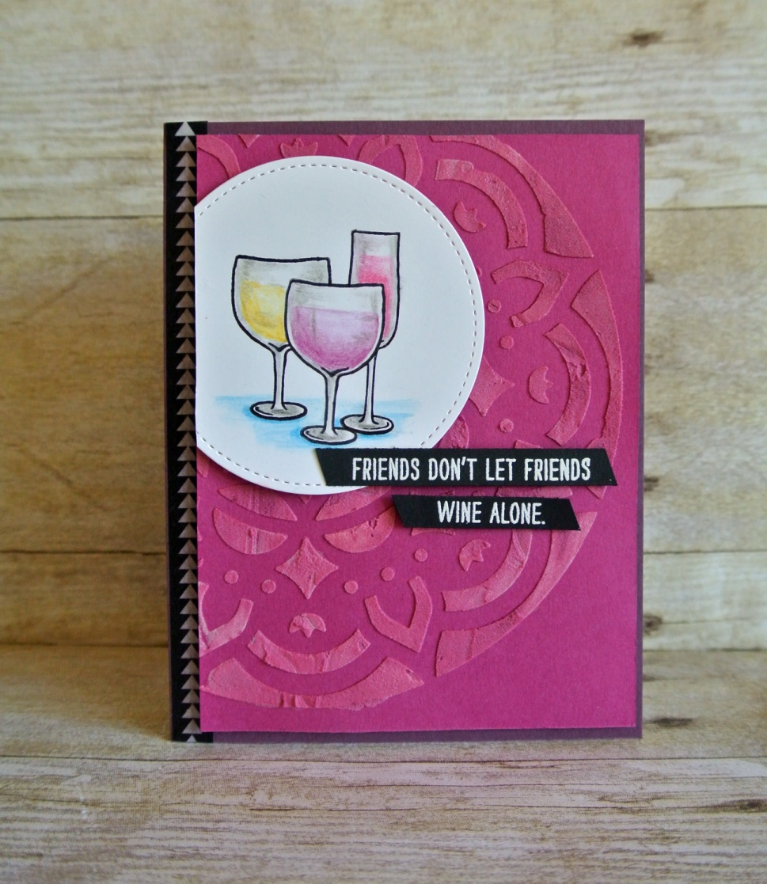
All images © 1990-2015 Stampin’ Up!®

Supplies:
- Stamps: Mixed Drinks (141936 p)
- Paper :
  - 144243 Berry Burst Cardstock (8-1/2 x 5-1/2, scored at 4-1/4)
  - 144242 Fresh Fig Cardstock (3-3/4 x 5-1/4)
  - 121045 Basic Black (3-1/2 x 2))
  - 100730 Whisper White (3-1/4 x 3-1/4)
- Ink : 140931 Basic Black Archival, 145406 Whisper White Craft
- Other : 145372 Stitched Shapes Framelits Dies, 143263 Big Shot, 141709 Watercolor Pencils, 102845 Blender Pens, 141979 Embossing Paste, 144103 Pattern Party Decorative Masks, 142808 Palette Knives, 144090 Powder Pink Classic Ink Refill, 144088 Fresh Fig Classic Ink Refill, 127853 Silicone Craft Sheet, 109132 White Stampin’ Emboss Powder, 129053 Heat Tool, 144166 Pick A Pattern Washi Tape, 104430 Stampin' Dimensional, post-it note
Instructions:
- Fold Fresh Fig card base in half. Adhere a strip of Pick A Pattern Washi Tape to the left side. Trim ends flush with edges.
- Use a palette knife to place a little bit of Embossing Paste on a Silicone Craft Sheet. Add a drop of Powder Pink Classic Ink Refill and mix. Do the same to mix some Fresh Fig embossing paste, keeping the two colors separate.
- Place Pattern Party Decorative Mask over Berry Burst cardstock, positioning the mask as shown. Use a palette knife to spread the two colors of embossing paste over the mask. Try not to mix the colors too much, so there are a variety of shades. Remove mask and let dry. Clean mask and knife immediately with soap and water.
- Use Stitched Shapes Framelits Dies (largest circle die) to cut a circle from Whisper White cardstock.
- Stamp the center glass of wine with Basic Black Archival ink. Stamp again on a Post-It note and cut out the image. Place cut-out over stamped image to mask the center glass and stamp the other two glasses.
- Use Rich Razzleberry, Daffodil Delight, Melon Mambo, Pacific Point, and Basic Gray Watercolor Pencils to color the images and Blender Pens to blend as shown. Adhere to Berry Burst layer with dimensional and trim left side flush with edge.
- Use dimensionals to adhere Berry Burst layer to card base.
- Stamp and emboss sentiment in white on Basic Black cardstock. Trim sentiment into two narrow strips and cut ends diagonally. Adhere to card with dimensionals.
- Enjoy!

